CREATE A DATABASE IN CLOUDANT DB

|  |  |
| --- | --- |
| DATE | 14-Nov-2022 |
| TEAM ID | PNT2022TMID43101 |
| PROJECT NAME | IOT Based Smart Crop Protection System for Agriculture |

**Step 1 :** Utilize your account information to log in to IBM Cloud**. Step 2 :** access the resource list

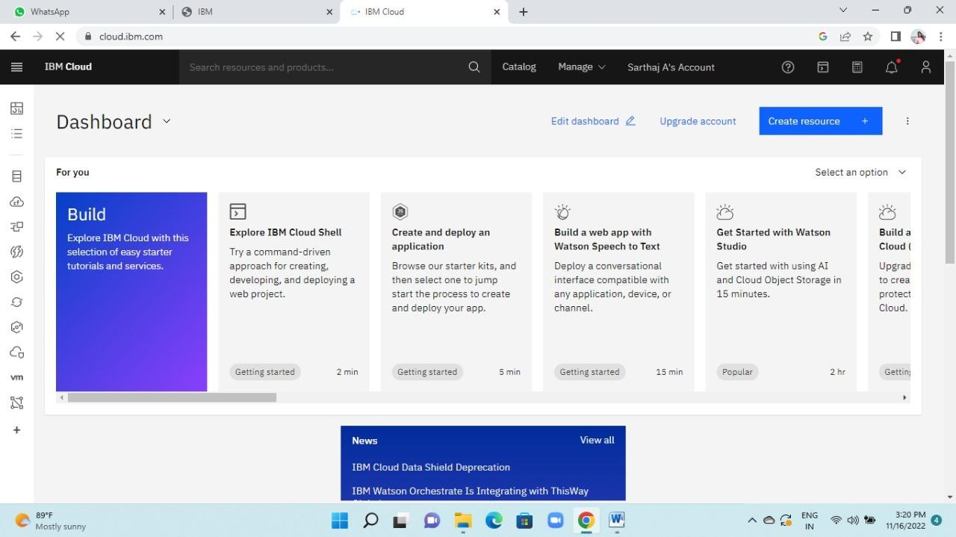

**Step 3 :** Select the data base from the resource list where you can examine the cloudant service's active status by clicking on that cloudant.

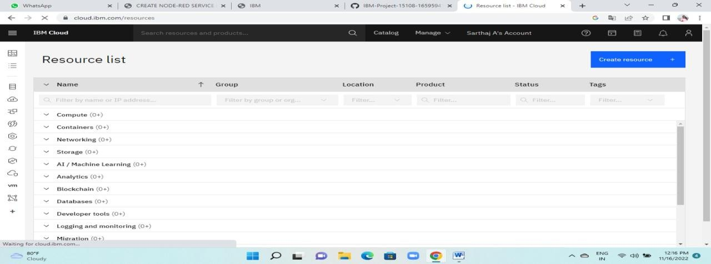

**Step 4 :** Following that, you may see "Launch Dashboard" in a blue box at the top and click on it.

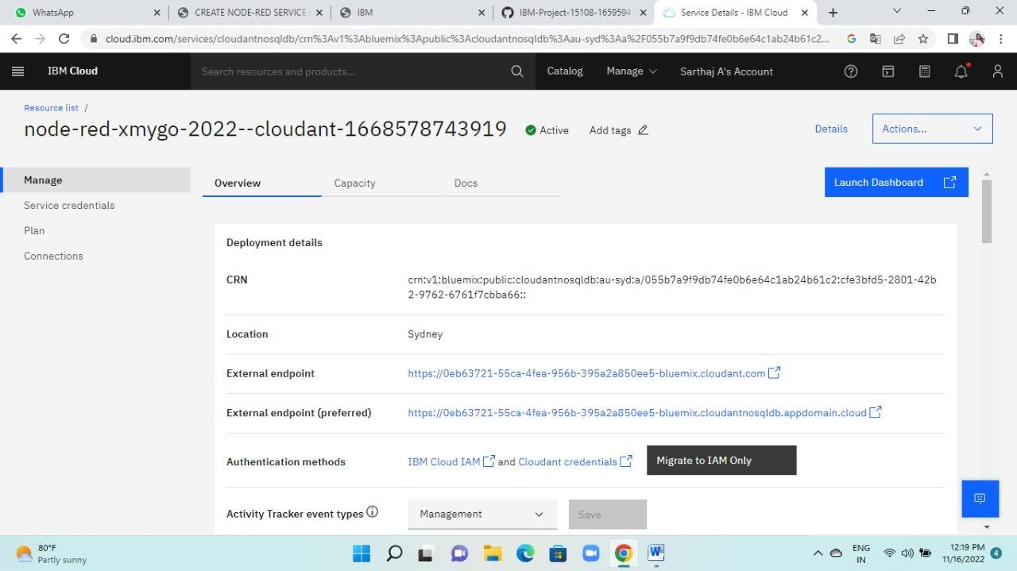

**Step 5 :** After that, it will open as shown below, and you can create a database by clicking the create database button as shown. then enter the information and select "create"

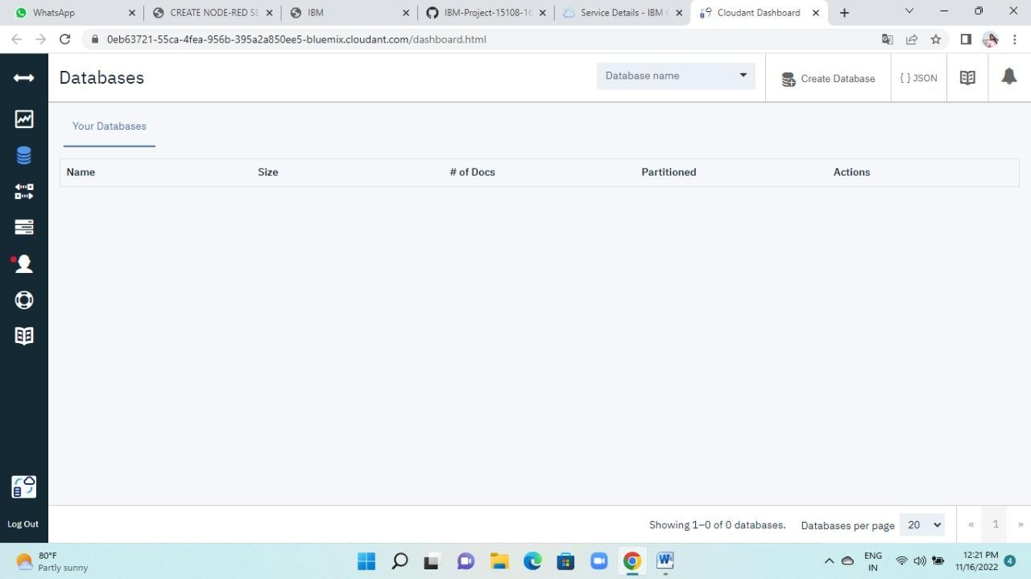

**Step 6 :** In order for the database to be successfully created

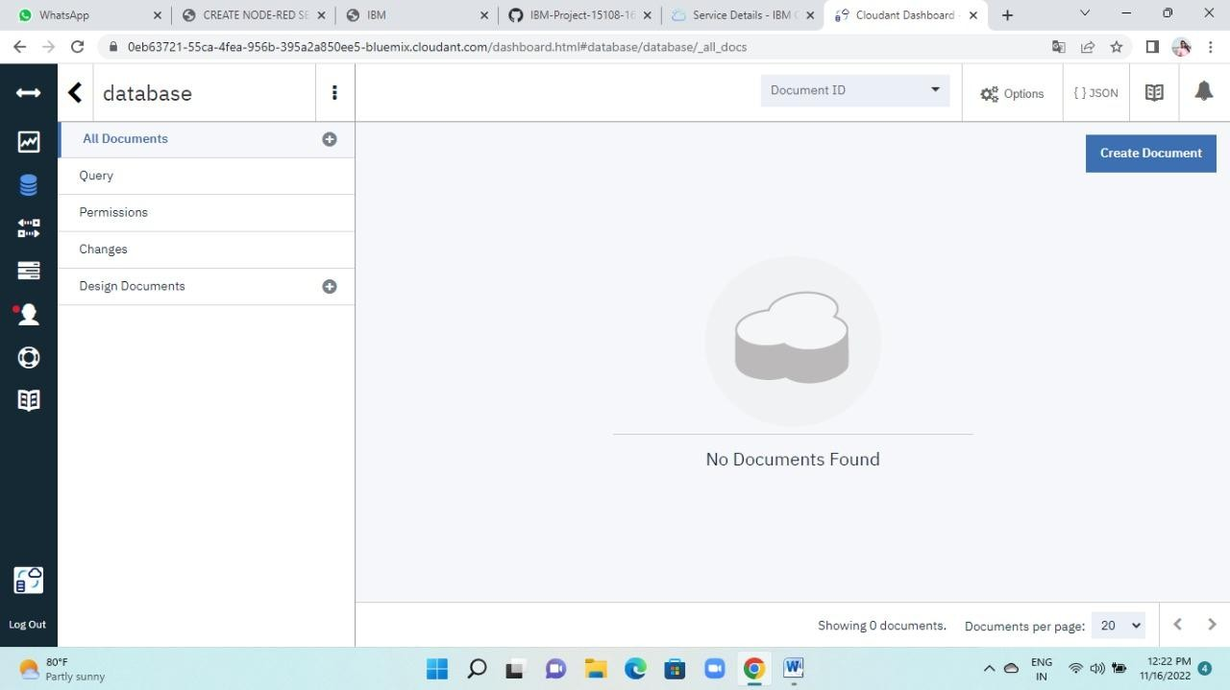

**Step 7 :** Now select Create Document from this database's menu to begin producing a document that will be used to create a database and store an image URL.

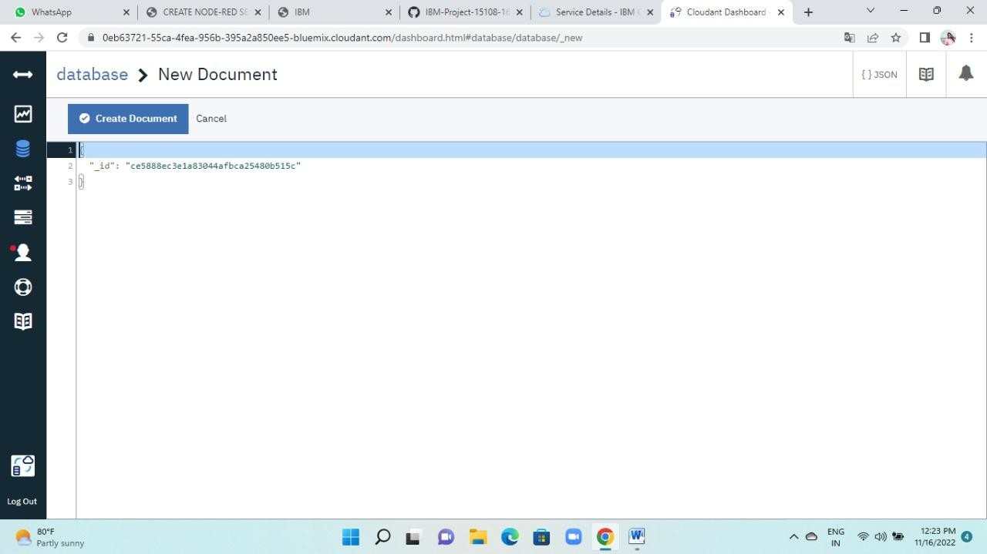

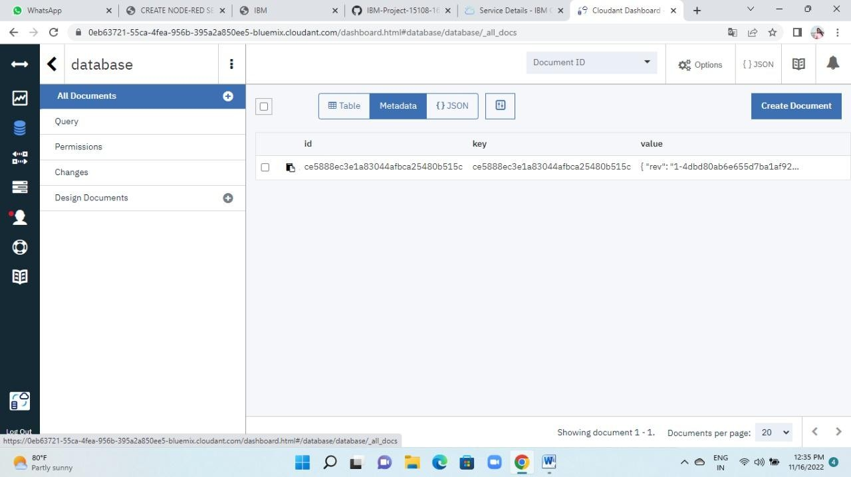

**Step 8 :** Consequently, a document is produced

